**Picker**

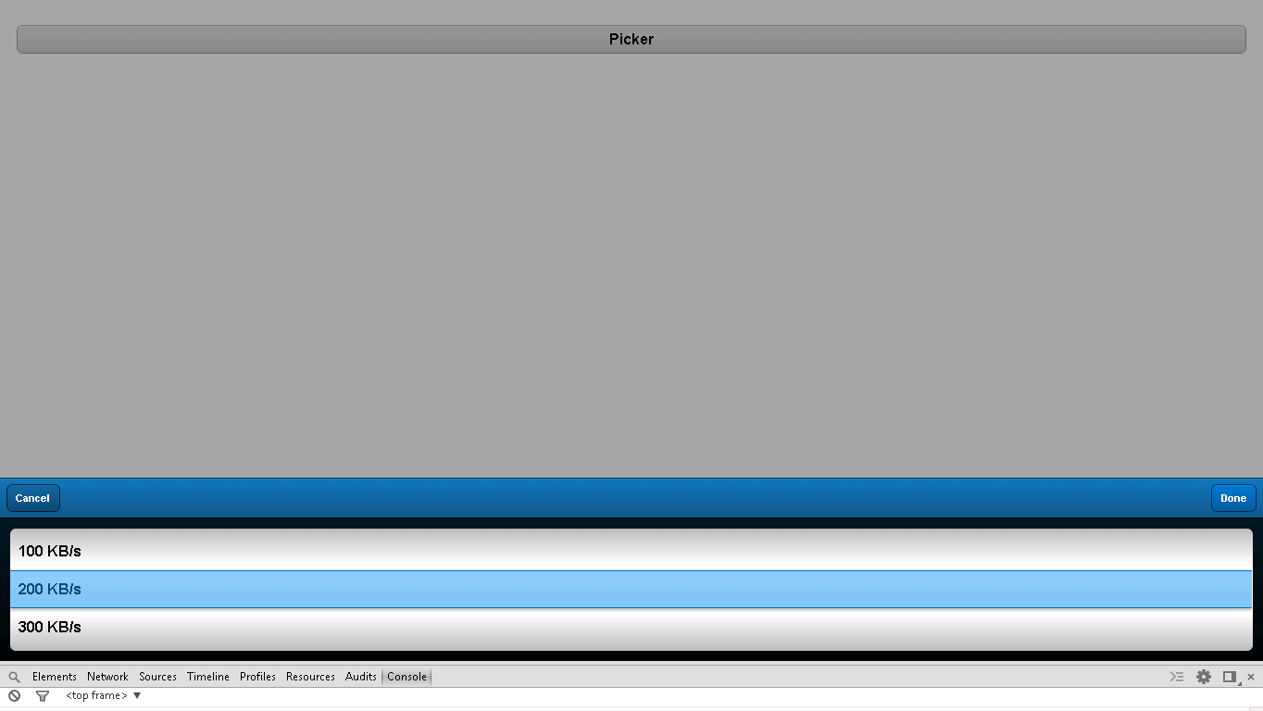

**Snapshot 1.1**

**Code:**

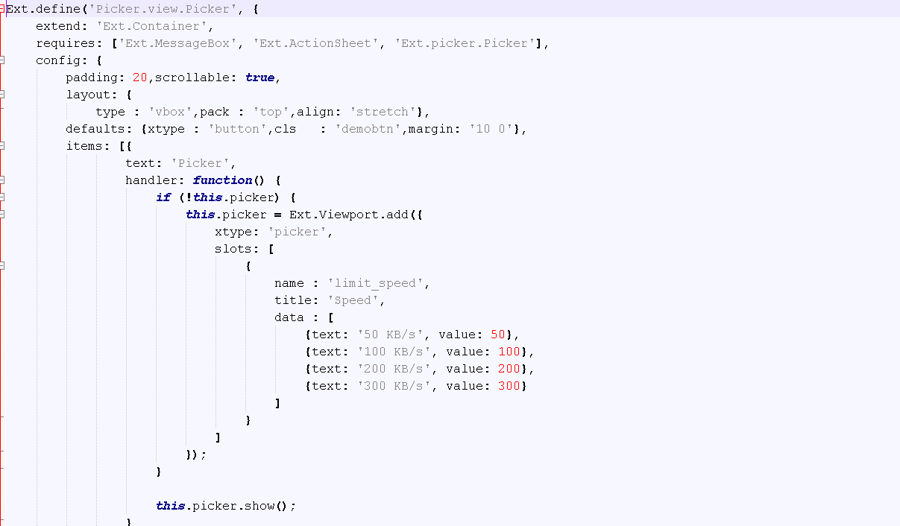

**Snapshot 1.2**

**handler: function()**  :-> function to add picker to your application

**{**

**if (!this.picker) {**

**this.picker = Ext.Viewport.add({**

**xtype: 'picker',** :-> Adds picker to your application

**slots: [**

**{**

**name : 'limit_speed',**

**title: 'Speed',**

**data : [** :-> Data added to picker

**{text: '50 KB/s', value: 50},**

**{text: '100 KB/s', value: 100},**

**{text: '200 KB/s', value: 200},**

**{text: '300 KB/s', value: 300}**

**]**

**}**

**]**

**});**

**}**

**this.picker.show();** :-> calls picker function

**}**

**Checkpoints**

1. Check carefully with your indentations as if you will miss any of the braces by mistake may reflect in compilation error.
2. See that your .js file starts with Ext.Define block and check that ends at the end of the program.
3. More than one items are separated by comma (,) separator and main program block of define is ended by semi colon (;)
4. Any value is assigned using colon (:) for example ui: 'confirm' and value is written inside single coats.
5. Items block starts with square brackets [] , which contains multiple members and also sub items.
6. Don’t forget to add entries of your files in app.js.

**Source Code**

